Questions for Electricity and Magnetism Unit

Which of the following is the complete list of the fundamental forces in nature?
- electricity, (b) magnetism, (c) gravity, (d) nuclear
- gravity, (b) electricity, (c) strong nuclear, (d) magnetism
- electromagnetism, (b) strong nuclear, (c) weak nuclear, (d) gravity
- friction, (b) thermodynamic, (c) electrodynamic, (d) geothermal
- magnetism, (b) strong nuclear, (c) friction, (d) electricity

Which of the following is attracted by a permanent magnet?
- nail, screw, brass ring, aluminum foil
- magnetite, nail, screw, penny
- washer, nail, screw, brass ring, ironwood
- steel, iron paper clip, screw, nail, magnet
- magnetite, penny, aluminum foil, nail

Five circular magnets are placed on a pencil as shown in figure 1. Which of the following statements is true?
- The magnetic pole arrangement is NS SN NS SN NS
- The magnetic pole arrangment is NS NS NS NS NS
- This demonstration illustrates two forces, electromagnetism and gravity
- Both (a) and (c)
- Both (b) and (c)
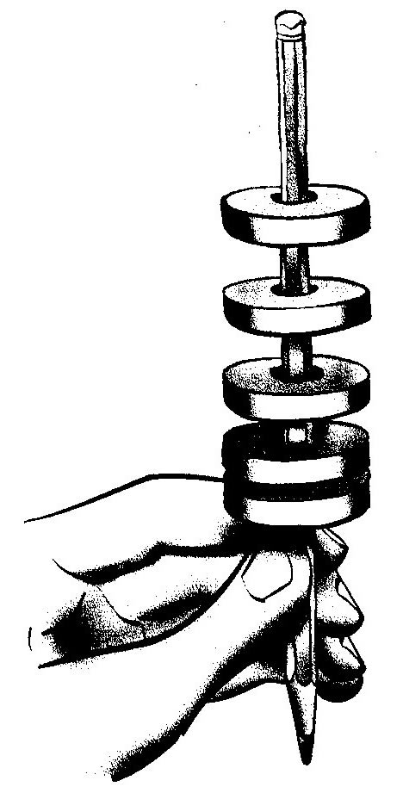

Which of the following is an example of induced magnetism?
- A permanent bar magnet
- The attraction of an iron nail by a permanent magnet
- The temporary magnetization of a paper clip by a permanent magnet
- Both (a) and (b)
- Both (b) and (c)

The following is a graph generated by students in a 4th grade class. Students placed nonmagnetic spacers to separate magnets, then recorded the number of washers that had to be placed on the opposite side of the balance to pull the magnets apart. Which of the following is true?
- The number of spacers is the independent variable, and the number of washers needed to overcome the force is the dependent variable.
- As the distance between the magnets increases, the force required to separate them decreases
- The number of washers is the dependent variable, and the number of spacers between the magnets is the independent variable
- This graph illustrates an inverse square relationship
- All of the above
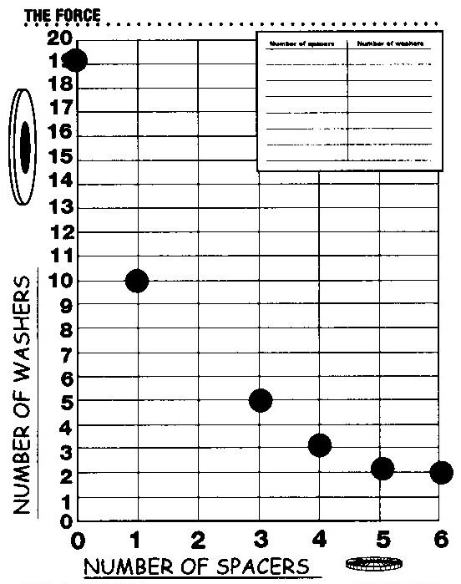
Which of the following is true?
- When two spacers separate the magnets, one must use the weight of approximately 5 washers to separate them
- The relationship between the number of spacers and the number of washers used to separate them is a direct , linear relationship
- The independent variable is the number of washers needed to separate the magnets
- The number of washers required is proportional to the force required to separate the magnets.
- The closer the magnets are to each other, the easier they are to separate.

Which of the following is a good way to make a compass to detect the Earth’s magnetic field?
- Hang a circular magnet by thread from the ceiling
- Heat a permanent magnet, then place it on a table top
- Place a needle on top of a floating cork
- Heat a nail, place it on top of a permanent magnet, then balance it on its head
- None of the above will work

Which of the diagrams indicates a circuit that will cause the light bulb to glow?
(a) 1, 5
(b) 4, 5
(c) 1, 2, 3
(d) 2,4,3
(e) 1,3, 5
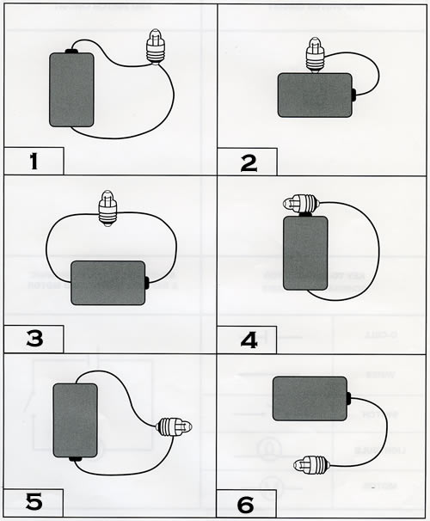

Two balloons are rubbed on a sweater. Which of the following are true.
- the two balloons will be attracted to each other
- The balloons acquired a positive charge from the wool due to an excess of electrons
- The balloons repel each other
- The balloons carry opposite static charges
- None of the above

Examine the diagrams below and specify which ones will light the bulb and/or turn the motor.
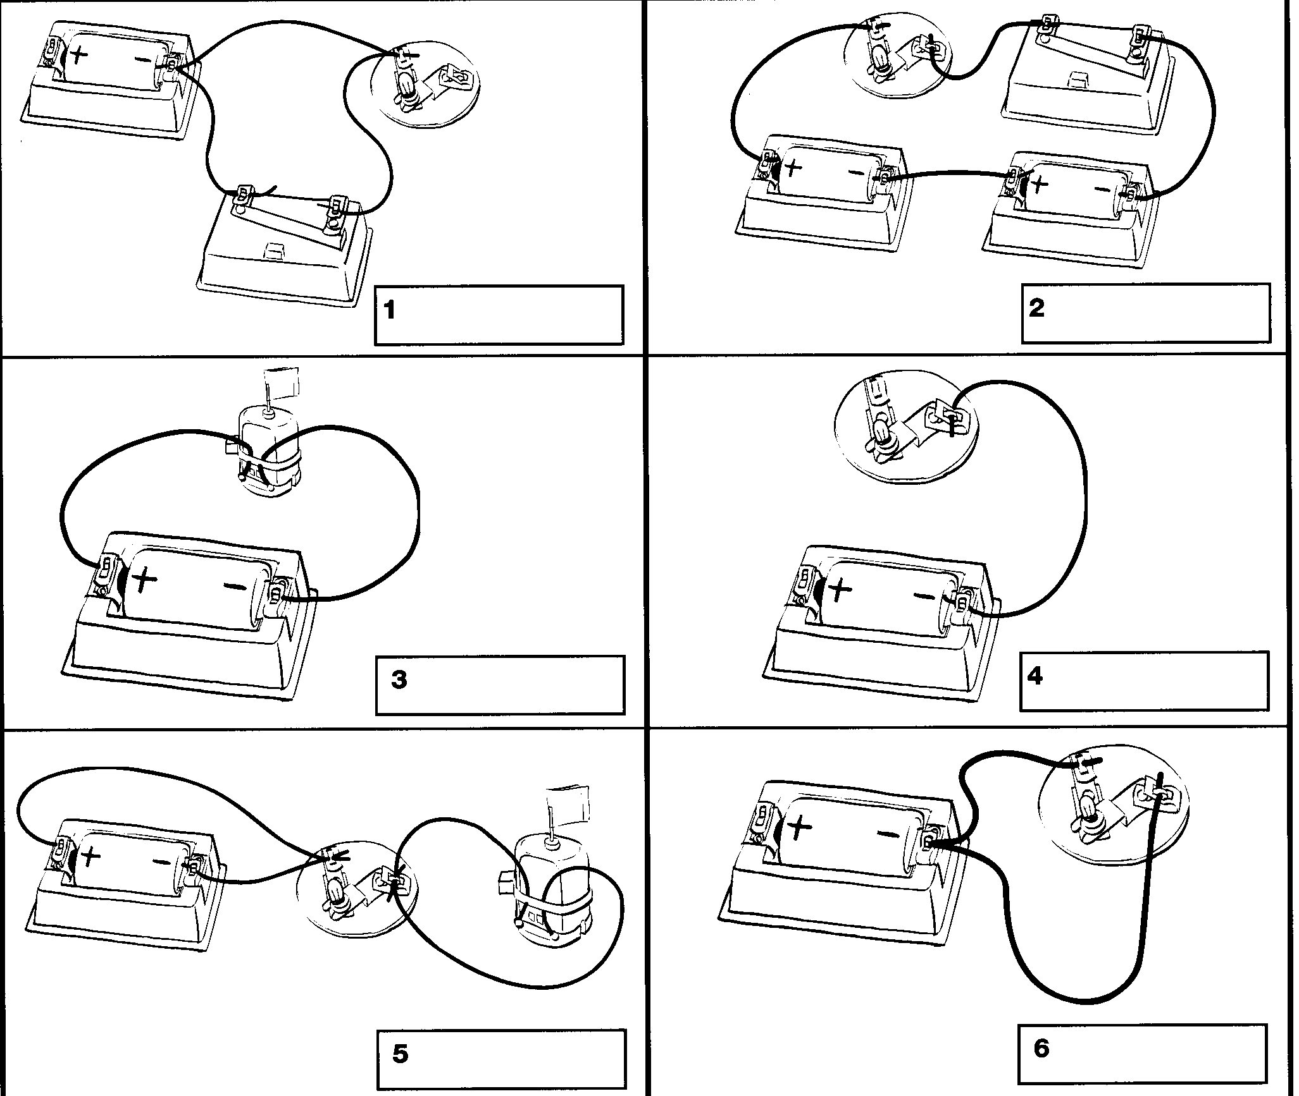

Questions related to the environment – from the field trip

All of the following ecosystems are found in the mountains of Southern California, except

- Oak woodland
- Riparian
- Mixed coniferous forest
- Chaparral
- Broadleaf deciduous forest

Conifers and oaks in Southern Calilofnia are more likely to be found on which slope of the mountain?
- North
- South
- East
- West
- They are distributed equally on all slopes

Which of the following fire-survival strategies is most common in plants of the chaparral?
- Resinous cones that break upon when scarified by fire
- Stump sprouting from roots
- Thick, fibrous, fire-retardant bark
- Fireproof seeds
- None of the above strategies are found among chaparral plants

GPS devices are used by scientists to do which of the following?
- Determine the distance between plant populations
- Determine the latitude and longitude of study plots
- Determine the slope and aspect of a study site
- All of the above
- None of the above

The most important limiting factor for plant growth in Southern California mountains is:
- light
- water
- minerals
- carbon dioxide
- heat

Which of the following is true?
- The evaporative demand is greater on south-facing slopes than on east-facing slopes
- Precipitation increases with elevation in the San Gabriel mountains
- Mediterranean ecosystems may experience summer rain, but little or no rain in the winter.
- All of the above
- None of the above

The San Gabriel Mountains are unusual mountains in North America because
- They are made primarily of granite
- They are part of the Transverse Range, running primarily east/west
- They support fauna (animals) characteristic of the Southeast United States
- They are composed primarily of unconsolidated sedimentary rocks
- The San Gabriel Mountains have no dikes

