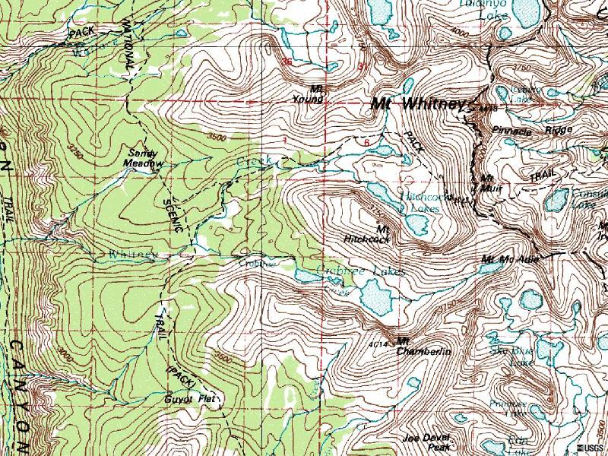 |  | - N from Sandy Mdw to un-named lake.  - SE up small valley to top of ridge.  - E along ridgeto col.  - SW down vallley to creek  - Down creek to creek junction  - E up creek to 3600 meter line.  - Climb cliff to summit  - What elevation are you now at?
 | x  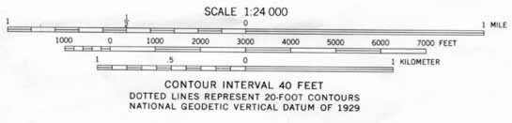 | - Place a compass on your map with N pointing to the top of the page.  - E on unimproved dirt road one mile  - Turn N on primary higway one half mile  - Turn right at school  - Travel E on trail 3/4 mile to creek.  - Follow creek 1/4 mile S to spring

